Programming Project 2
Due Date Feb. 16 11:59; late Feb. 18 11:59 , -30 points
Overview:
This assignment focuses on the design, implementation and testing of a Python program which uses control structures to solve the problem described below.
Problem Description:
Write a program using the cs1graphics library that creates a checkerboard as shown below: (this is just an example, see exact program requirements below)
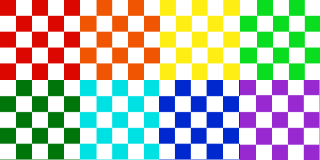

Be sure that the work is your own. You are encouraged to get help as needed from the TA’s or from your instructor in order to understand concepts, or debug your program, but NOT to write the code for you. Zeroes are given to any work that is not your own.
Requirements:
The cs1graphics library must be used to receive any points. The possible colors to be used are to be entered by the user and stored in a Python list structure. The number of colored checkerboards and the number of columns and rows within each checkboard should be entered by the user. The efficient use of loop structures to eliminate repetitive code will be part of your grade. There should be no more than 3 checkerboards per row of checkerboards.
Range for rows 2-6, range for columns 2-6, range for number of checkboards 2-6, number of color names should be 6
Code formatting and grading rubrics:
https://cs.slu.edu/~etchisonjs/csci1300/pguide.doc
How to submit:

Code, compile and test your program. Do not forget to include the appropriate comments in your program. See the programming guidelines link within Blackboard. Be sure to upload your project (pp2.py) to Blackboard by the indicated due date. You should not wait until the last minute when servers could go down.
You are given NO credit for programs that contain syntax errors and will not execute. You will be given partial credit if your program runs but the results are partially incorrect and/or incomplete.

